AWS Serverless Lab Guide

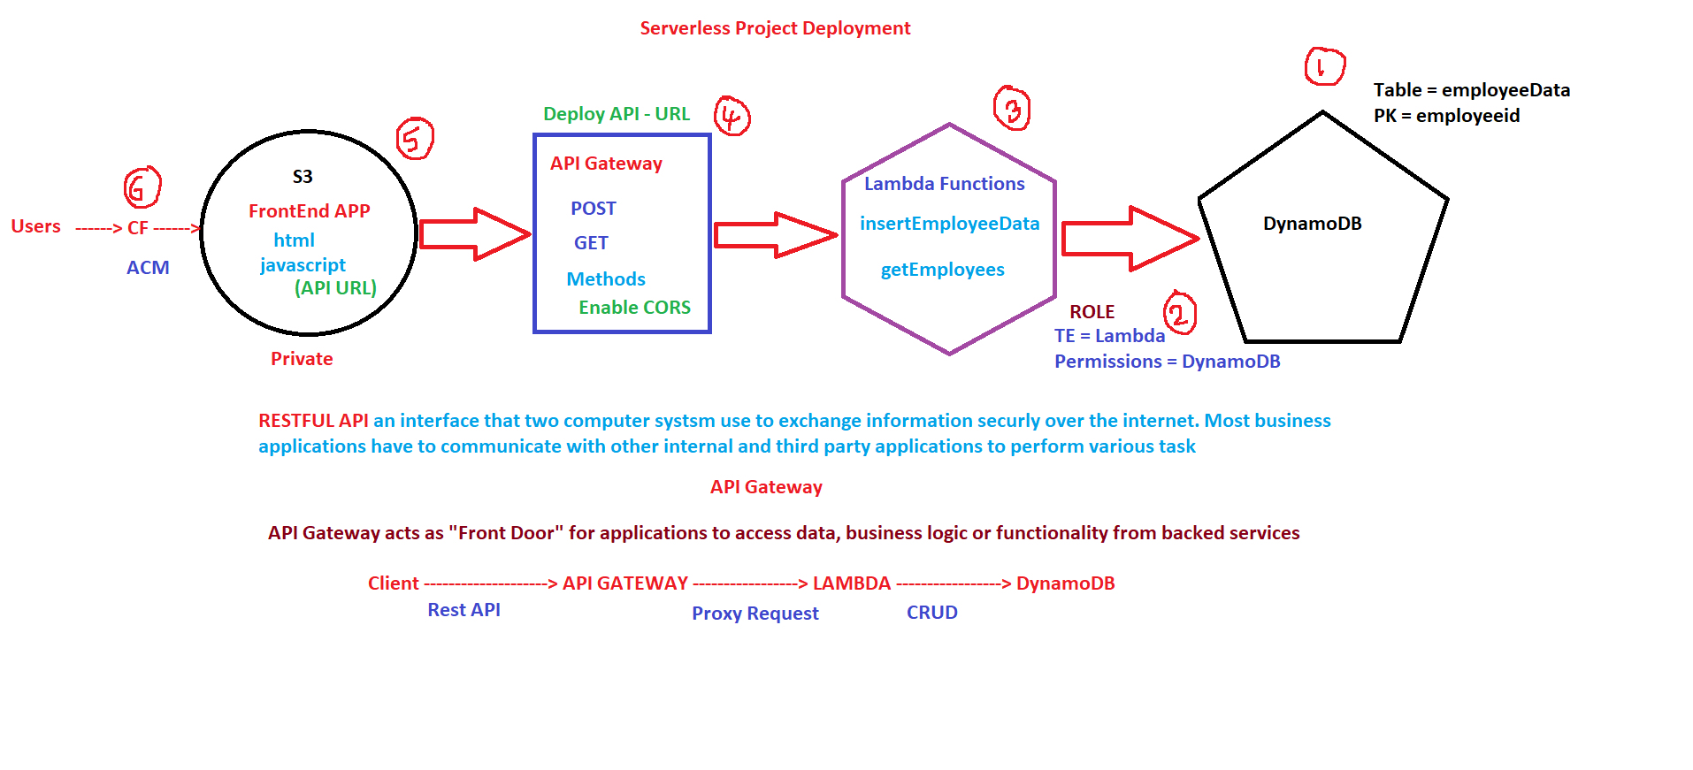

Step 1: Create DynamoDB Table
1. Open DynamoDB
2. Create table
3. Table name: `employeeData`
4. Partition key: `employeeid` (String)
Step 2: Create IAM Role
1. TE: Lambda
2. Permission: dynamo Db full access
Step 3: Create Lambda Function
1. Open Lambda → Create Function
2. Code and deploy refer (EmployeeData.py)
Step 4*: Very Very IMPORTANT Step
Create API Gateway (REST API)
- API Gateway → REST API → Build
2. Create resource `/employees`
3. Methods: GET, POST (Use Lambda Proxy integration: ✔ (checked))
4. Create resource `/employees/{employeeid}`
5. Methods: GET, PUT, DELETE (Use Lambda Proxy integration: ✔ (checked))
6. Enable CORS
7. Save employeeid
8. Deploy API --- you will get https://yodrgw88zi.execute-api.ap-south-1.amazonaws.com/employeeapi
Create Resources like below only
└── /employees
├── GET
├── POST
├── OPTIONS
└── /{employeeid}
├── GET
├── PUT
├── DELETE
└── OPTIONS
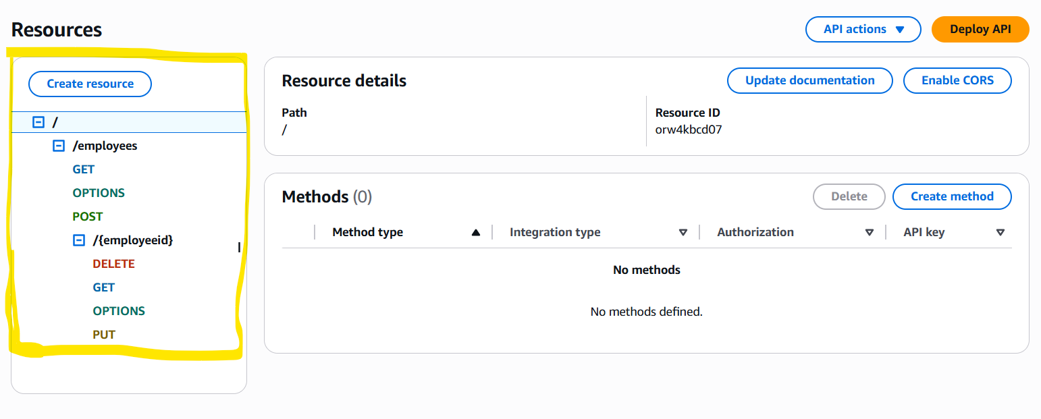

Step 5: Create S3 Bucket for Hosting
Note: Paste https://yodrgw88zi.execute-api.ap-south-1.amazonaws.com/employeeapi in scripts.js
- Open S3
2. Create bucket
3. Upload `index.html` and `scripts.js`

Step 6: CloudFront Distribution
- Open CloudFront → Create Distribution
- Domain name
- create certificate
- setting edit default root object index.html
- create record

